Coordinated by Wayne State University, Michigan Technological University & Belle Isle Conservancy with funding from the MI Departments of Natural Resources, Environmental Quality, & Agricultural and Rural Development

Preventing the Spread of Invasive Species in Michigan

ByDawn Michalakmichalakd@bcschools.net

Lesson Overview

This lesson is intended to be taught at the beginning of the school year. Many of the vocabulary words will be used across science topics. It is also a learning activity that can easily be used again for introducing topics. Introduce vocabulary words one at a time and post vocabulary posters with words, definition and sentences. Reveal one word at a time:

1.Define word
2.Use word in a sentence
3.Ask students for examples. Instead of raising hands to respond, students stand. Teacher calls on three students who remain standing. The others sit down. Teacher addresses any misconceptions and may ask for more examples. Responses could be listed on the poster and used as a reference. While the teacher records responses, students can turn to a neighbor and teach each other the meaning of the word.

Target Grade/Subject: Grades 1-5, Science vocabulary
Time: 50-60 min.

Sources Consulted
Belle Isle Aquarium http://detroitaquarium.weebly.com/invasive-species.html

GLEAM: Great Lakes Environmental Assessment and Mapping Project. http://greatlakesmapping.org/great_lake_stressors/2/zebra-and-quagga-mussels
National Research Council. (2012). A Framework for K-12 Science Education: Practices, Crosscutting Concepts, and Core Ideas.Committee on a Conceptual Framework for New K-12 Science Education Standards. Board on Science Education, Division of Behavioral and Social Sciences and Education. Washington, DC: The National Academies Press.

Next Generation Science Standards https://www.nextgenscience.org/

Science Buddies www.sciencebuddies.org

Smithsonian Marine Station. https://www.sms.si.edu/irlspec/Nonnatives.htm

Learning Objectives
At the end of this lesson, students will be able to:
- correctly use the vocabulary words as they engage in the eight practices of science and engineering.

Michigan Science Standard Addressed
3-LS4-3 Biological Evolution: Unity and Diversity
Construct an argument with evidence that in a particular habitat some organisms can survive well, some survive less well, and some cannot survive at all.
4-LS1-1 From Molecules to Organisms: Structures and Processes
Construct an argument that plants and animals have internal and external structures that function to support survival, growth, behavior, and reproduction.

List Materials & Quantities Needed
- 8.5 x 11 plain paper one per student
- markers
- magnets or tape to post the posters
- sticky notes (optional)
- computer and projector (optional)

Advanced Preparation
- Print 7 small posters (12x14) one for each vocabulary word(See end of lesson for posters)
- Print: two posters(12x14) One for ‘types of hints’& one with ‘game rules’ or print handouts of each (See end of lesson)
- cards with vocab words (one set of 7 for each group of six students)
- sort student names into groups of six (for game)

New Vocabulary
Native invasive model patterns
Phenomena variables non-native ballast water

Focus Question(s)

Introduction

Did you know we have space invaders right here in Michigan? However, they are not from outer space. But they are stealing space from plants and animals that live in Michigan. These invaders or invasive species are taking over causing some Michigan plants and animals to nearly die out. We are going to learn some new terms to help us understand this problem and what we can do about it.

Classroom Activities
Teacher may want students to sit in a circle.
Introduce words one at a time and post vocabulary posters with words, definition and
sentences. Reveal one poster at a time.

Process for introducing each term:
1. Teacher defines each word (see below)
2.Teacher uses each word in a sentence (also provided below)
3. Ask students for examples. Instead of raising hands to respond, students stand. Teacher
calls on three students who remain standing. The others sit down. Teacher addresses any
misconceptions and may ask for more examples. Responses could be listed on the poster or
added using sticky notes. Posters will remain up and used as a reference. While the teacher
records responses students can turn to a neighbor and teach each other the meaning of the
word.

Native species
Teacher says:
Native species is a species that occurs in an area naturally; it has lived in an area for thousands of years.
The white river crayfish is a native species to Michigan; it occurs here naturally.
What are some examples of other species native to Michigan?

Non-native
Teacher says:
A non-native species is a species that has not naturally occurred in a habitat that has been introduced to an area by humans.
The zebra mussel is a non-native species. It originally is found in Eastern Europe.
What are some examples of other non-native species in Michigan?
Video definition show first two minutes of clip: https://www.youtube.com/watch?v=J-ftiWffNTc

Invasive species
Teacher says:
An invasive speciesis “a plant or animal that is non-native (or alien) to an ecosystem, and whose introduction is likely to cause economic, human health, or environmental damage in that ecosystem. Once established, it is extremely difficult to control their spread.”
The sea lamprey is an invasive species and attach to fish leaving round scars.
What can other invasive species do?
http://detroitaquarium.weebly.com/invasive-species.html
video for upper ele (6:15 min.):https://www.youtube.com/watch?v=yIgysZ5Hho8
video for lower ele (6:37 min.): https://www.youtube.com/watch?v=UyvPxU6LUu0

Ballast water

Show: “Silent Invaders" Ballast Water 2013
https://www.youtube.com/watch?v=KYIJdhw8NcA2:54 min video about ballast water & Great Lakes
Teacher says:
“Ballast water is taken onto or discharged from a ship as it loads or unloads its cargo, to accommodate changes in its weight.”
The ship empties its ballast water when it takes on cargo.
What kinds of invasive or non-native species are transported in ballast water?

Phenomena
Teacher says:
Phenomena are observable events that we, as scientists, try to explain or make sense of.
Phenomena that I want to investigate are leaves changing color, the grass being wet in the morning, or how sea lamprey make circular marks on trout and salmon.
What is a phenomena you would like to investigate?

Models
Teacher says:
Models can be lists and simple sketches, or three-dimensional representation, generally in miniature,to show the construction or appearance of something. (dictionary.com)
Making a model of a trout fish with a sea lamprey attached for my science project helped me explain how invasive species can harm Great Lakes fish.
What types of models have you created? How did they help you understand a concept better?
Patterns
Teacher says:
Patterns are regularly occurring shapes or structures and in repeating events and relationships
The stripes on the side of a zebra or the stipes on the side of a zebra mussel are patterns that help us recognize that they are different from our native species.
Describe a pattern you have observed.

Variable
Teacher says:
The things that are changing in an experiment are called variables. ‘Scientists design an experiment so that they can observe or measure if changes to one thing cause something else to “change” in a repeatable way.’ (sciencebuddies.org)
The things that are changing in an experiment are called variables.
I want to find out if zebra mussels can filter algae out of water. The variables are the number of mussels added to the water and how many algae are in the water, measured by how green the water is.
What else can we change in the experiment? (Use different numbers of mussels; use different types of algae; do the experiment at a different temperature; and so on)

Introduce game:
Somewhat similar to the game Headbands, group of six or fewer sit in a circle.
1. One student holds vocabulary cards, showing one card without looking at it.
2. Others take a turn describing / defining the word for holder to guess. This is a reciprocal
teaching technique. The card holder does not ask the questions, but listens to the hints.
This will involve each child in the process instead of just answering yes or no questions.
The goal is for each child in circle gives a different hint.
3. Holder only guesses after each child has given a hint. (even if s/he knows the answer
after one or two hints)
4. If the holder doesn’t guess correctly s/he can look. Put the card on the bottom of the
pile and pass to the next person.
5. The person to the holder’s left becomes the new holder.
6. Play continues until the teacher calls time.

Rules:
No letter or rhyming hints.
Everyone gives a hint before the holder takes a guess.
Avoid passing.
Holder guesses after everyone has given a hint. S/he gets to look after guessing.

Types of Hints:
Fill in the blank
What the word does
Definition
Non-Example

Teacher can model different types of hints. Types of hints could also be posted for reference.

Teacher says:
An example using the term zebra mussel:
This is an example of a fill in the blank hint:
The _________ clogs water treatment and power plant pipes.
This is an example of what the word does:
This species has become invasive in the Great Lakes; it attaches to native species, ‘reducing their ability to move, feed, and breed, eventually killing them.’ (http://greatlakesmapping.org/great_lake_stressors/2/zebra-and-quagga-mussels)

Teacher says:
An example using the term variable:

Here I’m using a definition as a hint: The things that are changing in an experiment.
A non-example hint would tell the opposite of what the word means or does: Something that is kept the same throughout an experiment.

Other clues that could work are drawing a quick picture, acting out the word, giving a synonym
or antonym

Teacher should have groups listed/sorted prior to lesson. This will help with students staying on task. Students play game and teacher monitors groups. Listen for any misconceptions.

Conclusion: Whole group. Ask students for hints they heard or used during game that were new and helpful. Add new examples to poster. Address misconceptions.

For online games about invasive species:
http://detroitaquarium.weebly.com/kids-corner.html#invadergames

Assessment of Student Learning

Using a 8.5 x 11 sheet folded in quarters students write one word in each quarter square. They are to use the word in a meaningful sentence and draw a picture for each. This is a good way to check for understanding.

Fold a piece of white copy paper into quarters. In each square, write one of the science terms. Write a meaningful sentence using each word and draw a picture. The science terms must be spelled correctly. Each sentence needs to show that you understand what the word means. You may not copy the poster sentences.

See next page for examples of posters that could be used.

Native Species
species that occurs in an area naturally; it has lived in an area for thousands of years.
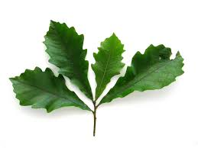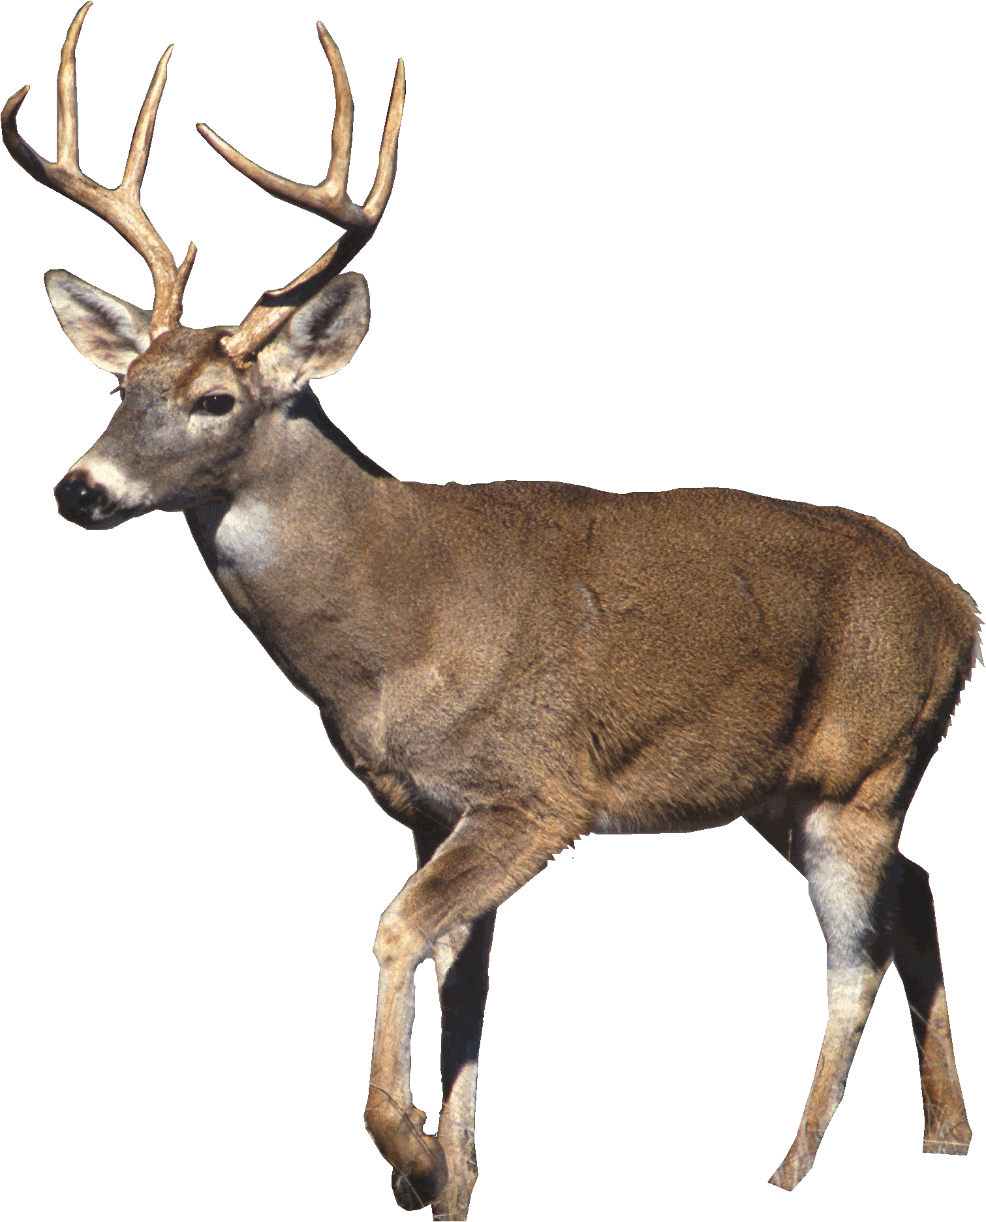

Non Native Species
Species that has not naturally occurred in a habitat that has been introduced to an area by humans.
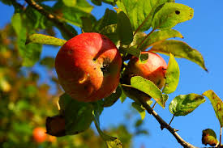
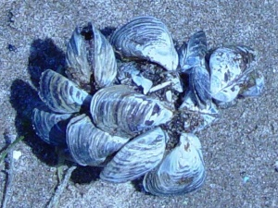
Invasive Species
“A plant or animal that is non-native (or alien) to an ecosystem, & whose introduction is likely to cause economic, human health, or environmental damage in that ecosystem. Once established, it is extremely difficult to control their spread.”http://detroitaquarium.weebly.com/invasive-species.html
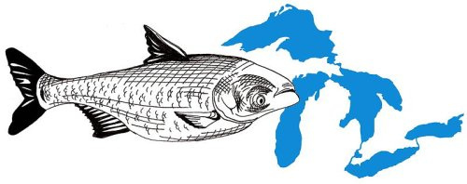
Ballast water
Water taken onto or discharged from a ship as it loads or unloads its cargo, to accommodate changes in its weight.”

Phenomena
observable events that we, as scientists, try to explain or make sense of.
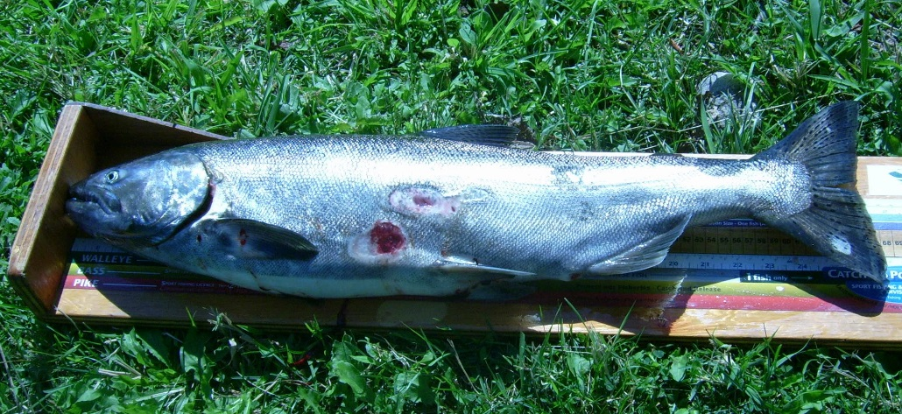
Models
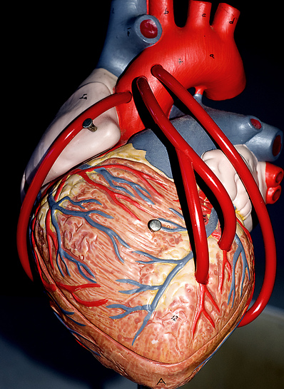
lists & simple sketches, or three-dimensional representation, generally in miniature, to show the construction or appearance of something. (dictionary.com)

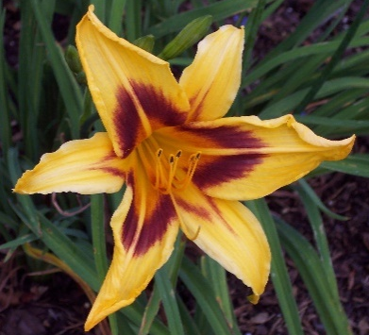
Patterns
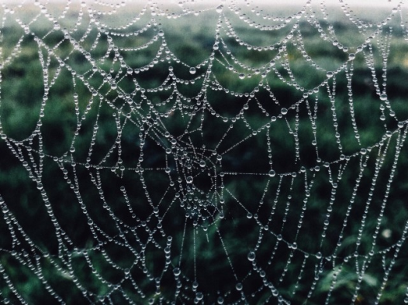
regularly occurring shapes or structures & in repeating events & relationships
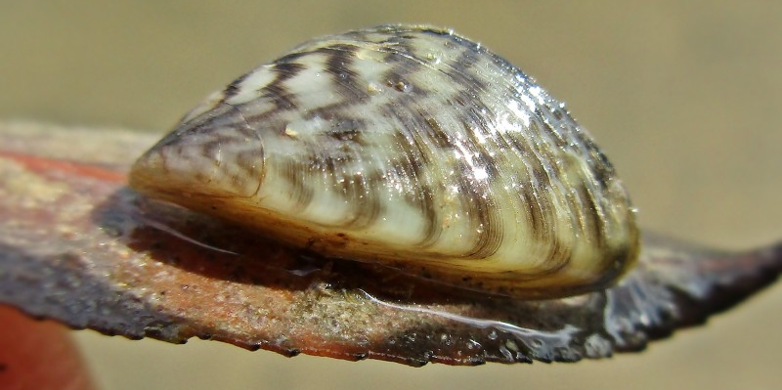
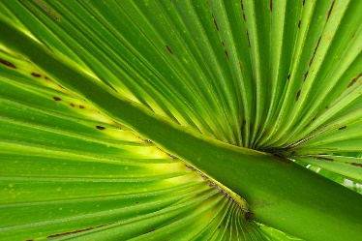

Variables
things that are changing in an experiment are called variables.’ (sciencebuddies.org)

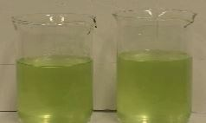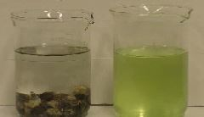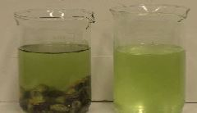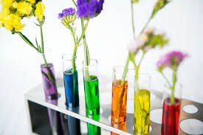
Before mussels first added 90 min later
Rules:
- No letter or rhyming hints.
- Everyone gives a hint before the holder takes a guess.
- Avoid passing.
- Holder guesses after everyone has given a hint. (S/he gets to look after guessing.)

Types of Hints:
- Fill in the blank
- What the word does
- Definition
- Non-Example

